Title: Ecology and economics of alternative native bees for almond pollination

Author names and affiliations.
Insu Kohª, Eric V. Lonsdorf^{a,b}, Derek R. Artz^{c}, Theresa L. Pitts-Singer^{c}, Taylor H. Ricketts^{a,d}.

a: Gund Institute of Ecological Economics, University of Vermont, Burlington, VT 05405, USA.
b: Biology Department, Frank and Marshall College, Lancaster, PA 17604
c: Pollinating Insects Research Unit, USDA-Agricultural Research Service, Logan, UT 84322, USA.
d: Rubenstein School of Environment and Natural Resources, University of Vermont, Burlington, VT 05405.

Corresponding author
Insu Koh.
Gund Institute of Ecological Economics, University of Vermont, Burlington, VT 05405, USA.
ikoh@uvm.edu, 802-656-2596.
Abstract [<=200 words]

Bees provide essential pollination services to many crops. Recently, growers started to integrated alternative native managed bees (e.g., blue orchard bee) into orchard systems. However, there is still less known about the management recommendations for this managed bee. To help grower’s optimal investment choices on how many blue orchard bees and artificial nests should be provided, we developed and combined an ecological model of forging density of bees to predict almond yields and a function to predict nest establishment rates given artificial nest site density and number of released blue orchard bees using a field data set from a 151-acre almond orchard. We parameterized the model and conducted a cost-benefit analysis for all possible combination of three management options such as number of blue orchard bee to release, nest site density, and number of cavities per site. The ecological model showed foraging activity of blue orchard bee occurred near by their nests (averaging 80 m). Our simulation results highlighted that increasing nest site density with middle number of cavities (200 tubes) provided higher net benefits than providing additional blue orchard bees in the orchard. This study helps growers manage the native bees to increase economic net benefit from their orchards.

Graphical abstract

Highlights

Keywords: blue orchard bee, cost-benefit analysis, foraging density, net benefit.

- Introduction

Crop pollination by animal pollinators is an important ecosystem service for agricultural food production. Pollinators play an important functional role in the reproduction of most flowering plants including over one third of arable crops (Klein et al., 2007). Production of 70% of globally leading crops such as vegetables, nuts, and fruits, which account for 35% of global food production, is dependent on animal pollination (Klein et al., 2007). This animal-mediated crop pollination service has been estimated at €153 billion, which represents approximately 10% of value of the word crop production in 2005 (Gallai et al., 2009). Animal pollinators also contribute up to 40% of the world’s supply of a number of essential nutrients in human diet (Eilers et al., 2011). They are responsible for nutrition of over 50% of populations in some developing countries (Ellis et al., 2015). Therefore, maintaining animal pollinator supply in pollinator-dependent crop systems is critical to enhance the stability of agricultural production (Garibaldi et al., 2011).
Bees, the major group of animal pollinators in temperate region (CITE Kevan 1999), are widely integrated in crop pollination services. Globally, honey bee (Apis mellifera), which is native to Europe and Africa but not North America, is predominantly managed to enhance a wide variety of crop production (National Research Council, 2007). For example, 60 – 75% of U.S. commercial hives are transported from Florida and Texas to California in early spring to pollinate the 0.8 million acres of almonds (CITE). Ecology and economics of this managed honey bees in agricultural production have been well documented (Champetier et al., 2015). However, recent ongoing declines in domestic honey bee stocks in USA and EU increase a risk at agricultural food supply (Goulson et al., 2015; Kerr et al., 2015; Potts et al., 2010). Native, wild bee communities also provide substantial crop pollination service where sufficient habitats exist for maintaining their populations. For example, native bees directly benefit to crop pollination regardless of honey bee abundance (Garibaldi et al., 2013). Indirectly, they complement the pollination shortage by honey bees (Kremen et al., 2002) or enhance honey bee pollination services biologically (Brittain et al., 2013; Greenleaf and Kremen, 2006). Another important pollinators are ‘alternative managed’ bees that are being developed to substitute honey bees’ role in managed pollination. Alternative managed bees are getting more important in large orchard systems because growers of large intensive orchard systems with insufficient natural habitats for wild bees are being suffered by a rapid increase of honey bee hive rental cost due to ongoing honey bee loss and increasing cultivated areas.
Because of a long history of use in agriculture, there are well-defined recommendations for how to use honey-bees in crop pollination (CITE, Delaplane and Mayer 2000) but management recommendations for alternative managed bees is an ongoing focus of research. The blue orchard bee (Osmia lignaria, hereafter referred as BOB) is one of few managed native bees for orchard pollination in the United States. Recent studies show that when commercially raised adult BOB females were released in orchards they successfully built nests in the provided artificial cavities and delivered pollination services often superior to honey bees for native fruit and nut trees such almond, apples, cherries, and plums in small (2 – 8 ha) orchard (Bosch and Kemp, 2000; Bosch and Kemp, 2001; Bosch and Kemp, 2002; Bosch et al., 2006). More recently, Artz et al. (2013) reveals that using BOBs along with honey bees at half stocking rate provide at least an equivalent nut yield as when using honey bees alone at full stocking rate in a large almond orchard (61 ha). Along with these recent founding, the effects of artificial nest site density, distribution, and colors on the BOB’s nest establishment, reproductive success, and almond yield have been studied (Artz et al., 2014).
Despite this increasing evidences on the efficacy of the managed native bee in orchard pollination, there is still less information about how much farmers should invest in introducing the alternative managed bees and artificial nests what is the net benefit of the management costs at the orchard level. This type of information can help grower’s decision. For example, a cost-benefit analysis of a managed bumble bee showed the marginal profits of bumble bee rental (rental cost, $10,000 ha⁻¹) for two different cultivars of greenhouse sweet peppers were $35,000 ha⁻¹ and 55,000 ha⁻¹, respectively (Shipp et al., 1994). For BOB in orchard system, farmers can find just couple of simple recommendations about BOB’s stocking rates. For example, approximately 250 and 300 nesting BOB females are recommended for pollinating an acre of apples and almonds, respectively, but the higher number of female BOBs actually should be released because the potential dispersal and mortality of BOBs lead low nest establishment rate (Bosch and Kemp, 2001). In addition, 1.5 – 2 times number of male BOBs should be released for female BOBs’ nest establishment (Bosch and Kemp, 2001). However, to further help in grower’s decision, we need to answer the cost-benefit questions of whether the costs of additional releasement of BOBs and additional provision of nest cavities and densities for increasing female BOB’s nest establishments and orchard pollination are worth comparing to net benefits of yields.
Here, we conducted the cost-benefit analysis of a native managed bee in orchard yields – specifically to determine optimal number of BOBs to release, density of artificial nest sites, and number of cavities in order to maximize the net value of the almond production. For this analysis, we used a published data set from an experimental study of BOBs’ nest establishment rate and almond yields (Artz et al., 2013). From this study, we learned the nest establishment rate as the function of number of released female BOBs and the artificial nest managements and analyzed the effects of the distribution foraging bees from their nests on almond yields to link economic costs and benefits. We also developed an ecological model to predict almond yields based on the estimation of the density of foraging bees on almond trees and other environmental variables. Then, we applied this developed model with our understanding on the function of nest establishment to calculate marginal net benefits of almond production according to the combination of three management options: (1) releasing additional number of BOBs, (2) placing additional nest sites (i.e., nest site density), and (3) providing additional number of artificial nest cavities per nest site. Through these analyses, we suggest a broader ecological economic framework for evaluating managed bees in pollination service.

2. Methods

2.1. Conceptual model for integration of blue orchard bees into orchard system
The ecological behavior of blue orchard bee makes easy to integrate them into orchard system. The blue orchard bee (BOB) are solitary, which means that each female one tends to own brood after mating. Each female BOB builds a nest in pre-existing cavities such as holes in plant stems. Within a cavity females construct individual cells to lay eggs and deposit pollen and nectar for feeding larvae (Bosch and Kemp, 2001). Being solitary, they prefer to nest gregariously. Because of this nesting behavior they also can build nests in artificial cavities such as hollow reeds, cardboard tubes, and straws which are bundled together provided by farmers (Bosch and Kemp, 2001). Once female BOBs build nests in these artificial cavities they start to forage to collect pollen from floral resources around their nest sites. This foraging activity provides crop pollination service and return yields to farmers.
To optimize net benefit of integration of this native managed bees in orchard system, farmers should decide to the provision of BOBs to release and artificial nests to install in their orchards (Fig. 1). Farmers purchase commercially raised BOBs and release them from the center point of orchard. When the BOBs are released, there are chances of potential mortality and dispersal to outside of orchard boundary to impede or reduce nest establishment in the provided nests in orchard. Therefore, three different management options such as releasing additional number of BOBs, increasing nest site density, and providing additional number of artificial cavities can increase the chance of the nest establishment by the released female BOBs. All of these options need additional costs. Therefore, farmers need to understand how the distribution of foraging bees from the activated nests impacts on orchard yields to link economic cost and benefit before they decide the amount of investment in providing BOBs and artificial nest sites and cavities.

2.2. Study system.
To investigate the economic cost and benefit of the integration of BOBs into orchard we revisited a published experimental study (Artz et al., 2013) that revealed the relationship between nest establishment rate and nest site density and reported almond nut yields at the level of almond tree. We briefly describe the study site, experimental design, and field data set that we obtained from the study. All further detailed information should be referred to the study directly.
The experimental study examined effects of nest site density on nest establishment rate of female BOBs and almond nut yields on a 61 ha conventional almond orchard near Lost Hills, Kern County, California (35°44′N – 119°53′W) in the southern Central Valley in 2011. In this orchard composed of 109 x 120 trees, the authors placed 151 honey bee hives and released a total of 64,000 female BOBs (Fig. 2A) and 153,600 male BOBs, which is half recommended stocking densities for honey bee colony (one hive per 0.4 ha) and for BOBs (1,050 female BOBs per ha). To provide nest sites with cavities for female BOBs, the authors hanged a plastic box that had a bundle of cardboard tubes with inserted paper straws (Fig. 2B and C). To examine the effects of nest site density on nest establishment and almond yields, they created low and high nest site density plots in the center of the square-shaped orchard that have 25 nest boxes with the bundle of 400 nest tubes (eight plots with white X in the center) and 100 nest boxes with the bundle of 100 nest tubes (four plots with blue X in the center), respectively (Fig. 2D). Therefore, all the twelve plots had equally 10,000 available nest tubes but the distance among nest boxes was apart at averagely 40 m (plot with low nest box density) and 20 m (plot with high nest box density) in any direction for the two different types of plots. From the center of each plot 4,000 fully emerged female and 9600 males (approximately 2.4 times as many males as females) were released on 15 February 2011. Their observation on nest establishment within nest boxes showed that nest establishment rate was higher in high nest box density plots (36.2% filled tubes of 10,000 tubes) than in low nest box density plots (19.3% filled tubes) significantly. However, the study reported that there was no significant difference in sampled nut yields (dry weight, kg per tree) between two nest box density plots (yellow circle in Fig. 2D). The average weight of dried nuts from the samples for a tree was 0.996 ± 0.175 kg tree⁻¹.

2.3. Ecological model of density of foraging bees.
To develop an ecological model of almond yields from trees, we first considered foraging density of bees in almond trees. To estimate the density of foraging BOBs in almond trees from the activated nests, we adopted a negative exponential distance decay function. A synthesis study on foraging pattern of bees clearly shows their foraging ability generally decreased exponentially with distance from their nests (CITE, Ricketts et al. 2008). The foraging function has a distance decay parameter, which is approximate to average foraging distance. Therefore, we used this exponential decay function with distance decay parameter for BOBs to predict their foraging density for individual tree. Additionally we weighted the decay function by the number of activated (filled) tubes of each nest box, which represent the pollination activity from each nest box as follows:
Eq. (1)
Here, BOB_{T} means the foraging density of BOBs for tree T (1, 2, 3, …, 200); N_{box} is total number of nest boxes; D_{i, T} mean the distance (m) between BOBs’ nest box (i) and tree T; P_{BOB} means the distance decay parameter for BOB; and A_{Nn} means the number of activated nest cavities (number of filled tubes) by female BOBs. In the similar way, we also calculated the density of foraging honey bees (HB_{T}) with the distance decay parameter for honey bees (P_{HB}).

2.4. Parameterization and prediction of almond yields
We used multiple linear regression model to parameterize the distance decay parameters of BOBs and honey bees and to predict the sampled almond yields using the foraging densities for BOBs and honey bees and two additional environmental variables. First, we calculated the densities of foraging BOBs and honey bees (BOB_{T} and HB_{T}, respectively) for selected trees for sampling nut yields by setting all the possible combinations of the distance decay parameters (from 20 m to 1000 m by 20 m) for two managed bees, which were equal to a total of 100 x 100 cases.
Second, for the two additional environmental variables, we considered bock (Block) and boundary (Dist_{bound}) effects of tree location that may capture potential biophysical variables to influence tree nut yields. We considered two block of north and south (Block, Fig. 2D). We calculated distance between trees and the orchard boundary (Dist_{bound}).
Then, we used these four variables (BOB_{T}, HB_{T,} Dist_{bound}, and Block) to fit the sampled almond yields of trees while we varied the distance decay parameters for BOBs and honey bees. In the regression model, the HB_{T}, BOB_{T}, and Dist_{bound} were log10 transformed. Lastly, we applied a model-selection process for all the 10,000 regression models to retain significant number of variables in the model based on Akaike information criteria (AIC). In the model-selection process, we retained the model with the lowest AIC for each of distance decay parameter sets. Through this process, we determined distance decay parameter set when the best-fit model (the highest r²) appeared. Then we used the best-fit model to predict almond yields.
Additionally, to validate and specified the regression parameters and distance decay parameters in the best-fit model, we derived Bayesian posterior distributions for the regression parameters and distance decay parameters. To complete this Bayesian specification, we assigned non-informative priors (~Normal (mean = 0, SD = 100)) to all the parameters in regression models including the decay parameters. All these processes were conducted in in R statistical environmental (R Development Core Team 2006). For the regression model selection process, we used MuMIn package (CITE) and confirmed that residuals of the regression model were normally distributed and were not spatially autocorrelated. We used RStan package (CITE) for the Bayesian computation that simulated three Markov chain Monte Carlo chains (MCMC; Gilks et al. 1996) for 20,000 iterations after a burn-in of 10,000 iterations.

2.5. Cost-benefit analysis
To conduct cost-benefit analysis we addressed three possible management options such as number of female BOBs to release, nest box density levels, and number of nest tubes per box. First, we added and reduced the extra number of female BOBs (10,000) to release. In this scenario, we also released the number of male BOBs associated with the number of female BOBs in this scenarios. Second, we increased nest box density level from low (1/40² m²) via medium (1/30² m²) to high (1/20² m²). Third, we marginally increased the number of nest tubes per nest box from 100 to 400 by 50. For all the scenarios combined with the three management variables, we applied current cost of purchasing BOBs and providing artificial nests to estimate total cost at entire orchard level (Table 1).
To estimate benefit (monetary value of almond nut yields) for those management scenarios, we need to combine nest establishment rate and the developed ecological model of almond yield (Fig. 1). We predicted nest establishment rate as a function of the number of released female BOBs and nest site density based on the additional insight from the experimental study (Fig. 3) and two assumptions: (1) nest establishment rate increases with number of released female BOBs and density of nest box and (2) number of tubes within nest box does not influence nest establishment rate within the inference range between 100 and 400 tubes per box. Then we reinterpreted the nest establishment rate in terms of the total number of activated (i.e., filled) nest tubes (TA_{N}) as the function of nest box density (Nest_{density}, m²) and number of released female BOBs (BOB_{female}):

. Eq. (2)

To incorporate this function into ecological model of foraging density for BOBs (Fig. 1), we made additional two assumptions: (1) spatial distribution of the total number of predicted filled nest tubes is evenly distributed across nest boxes and (2) sampled nut yield per tree predicted from ecological model is proportional of a tree nut yield. The first assumption allowed us to avoid a potential event that the distribution of activated nest cavities are spatially autocorrelated. Although we found spatial autocorrelation of the number of filled tubes in some of plots (four and three plots with high and low nest box densities, respectively) among the total of sixteen plots, it was difficult to conclude that there was a spatial autocorrelation from this one time experiment. Therefore, we simply assumed that there is no spatial autocorrelation issue in this scenarios. The second assumption allowed us to scale up the nut yields from sample to a whole tree. Nut yield data was only available at the level of the entire orchard not at the individual tree level. Therefore, we used a scale factor that was calculated from dividing average nut yield per tree (i.e., total yield from orchard / total number of trees = 214,131.8 kg / 13,080 trees) by average sampled nut yield per tree (i.e., sum of sampled nut yields / 700 sampled trees = 0.996 kg).
Using the developed functions and the selected regression model, we predicted almond nut yields, transformed it to monetary value, and calculate net benefit. For all the scenarios, we ran the best-fit regression model with the predicted number of activated nests across the simulated nest boxes and the parameterized coefficients from Bayesian analysis to predict sampled nut yields for individual tees in orchard. We scaled up this predicted sampled nut yields to tree yields and summed them to estimate an almond yield from the entire orchard level, and then we transformed it as market value using the price of nut at 2011 ($0.9 kg⁻¹) for estimating the benefit. Finally, we calculated net benefit by subtracting the scenario-based costs from the market value for simulated almond yields. We also calculated the 50% credible interval of the simulated net benefits using the regression coefficient parameters and distance decay parameters of the range between 25% and 75% that were derived by Bayesian computation.

3. Results
3.1. Foraging distance and nut yield prediction
Sampled almond yields were highly predicted by a regression model with three variables, the foraging density of blue orchard bees (BOB_{T}), block effect (Block), and distance to orchard boundary (Dist_{bound}). The peak of model fit (r²) appeared when the distance decay parameter of blue orchard bee (P_{BOB}) was set between 40 m and 100 m (Fig. 4A). This parameter range was also validated and specified by sampling posterior distribution of P_{BOB} (Fig. 4B). All the regression coefficients were significant at the 95% credible interval except for the intercept (Table 2). In the best fit model sampled nut yields increased with BOB_{T} and decreased with Dist_{bound} and the nut yields were higher for trees in South block than North (Fig. 4C and D). In the parameter space between 120 m and 400 m for P_{BOB} the selected regression model included the foraging density of honey bees (HB_{T}) with 1000 m distance decay parameter for honey bees (P_{HB}) instead of Dist_{bound} variable. However, BOB_{T} and HB_{T} variables were highly correlated (r > 0.9). This high correlation affected the negative relationship between HB_{T} and sampled almond yields. In the parameter space of P_{BOB} over 400 m the variables of foraging density of bees were not selected in regression models.

3.2. Net benefit
Net benefits varied with three management variables, which were the number of released female BOBs, nest box density, and the number of nest tubes per nest box. Estimated net benefit varied with the number of released female BOBs and nest box density when we set the fixed number of tubes (200) per nest box. For the high level of nest box density (1/20² m²) the net benefit increased up to $220,000 when 44,000 female BOBs were released then steadily decreased over the number of released female BOBs (Fig. 5A). For the other two levels of nest box densities, the highest net benefits appeared at higher number of released female BOBs than the high nest box density scenario (64,000 and 84,000 for medium and low levels of nest box density, respectively); however, the net benefits were lower than the highest net benefit in the scenario of high nest box density.
Estimated average net benefits also varied with the number of nest tubes per nest box and nest box density. The net benefit slowly increased with the number of nest tubes per nest box between 100 and 200 and rapidly decreased with high number of tubes (> 200) for all nest box density scenarios and for the number of 64,000 released female BOBs (Fig. 5B). The net benefit increased with nest box density; however, the uncertainty of them, which was predicted by 25% and 75% parameter sets in the regression model (Table 2), also increased (Fig. 5B). Therefore, although the highest net benefit was expected from the scenario with 200 nest tubes per nest box at the high level of nest box density (1 / 20² m²), its uncertainty was much higher than the scenario with 200 nest tubes per nest box at the medium level of nest box density (1 / 30² m²) for the 64,000 female BOBs, which was the same number of released female BOBs in the previous experiment study.
In the all the combined management options, the highest net benefit appeared in the scenario of 34,000 – 44,000 released female BOBs, high nest box density (1 / 20² m²), and 150 – 200 tubes per nest box (Fig. 6). The average net benefit influenced by the marginal changes in the number of nest tubes per nest box (±50) more than by the marginal changes in the number of female BOBs (±10,000) for the all three different levels of nest box density (Fig. 6).

4. Discussion
- Cost-benefit analysis highlights variation of net benefit according to management scenario
  - Summary of major findings: nest establishment, foraging density, net benefit.

- BoB nest activity is predictive nearby almond yield
  - BoBs don’t forage far from the nest
  - High density of nest boxes reduces distance between nest and trees

- Insight on other regression variables.
  - Density of foraging honey bees
  - Block effects
  - Boundary effects: relationship between foraging pattern and Dist_{bound}

- Decision analysis suggests $100k difference in outcome for 150 acres ($667 per acre)
  - ~ %10 of gross value of almond
  - 850,000 acres of almonds in CA (2014) scales this up to an effect of over $500 million

- Several limitations
  - Simplicity of nest establishment function. Spatial pattern of filled tubes.
  - Regression model fit (r²) is low, which is just about 17%.
  - Use the regression model to predict tree nut yield outside of experimental study block
  - Check whether variable BOB_{T} from different scenarios is within the ranges of the inference in the regression model
  - Include other costs such as orchard managements?

- Broad conceptual model and future study

Acknowledgements

References

Artz, D.R., Allan, M.J., Wardell, G.I., Pitts-Singer, T.L., 2013. Nesting site density and distribution affect Osmia lignaria (Hymenoptera: Megachilidae) reproductive success and almond yield in a commercial orchard. Insect Conserv Diver 6, 715-724.
Artz, D.R., Allan, M.J., Wardell, G.I., Pitts-Singer, T.L., 2014. Influence of Nest Box Color and Release Sites on Osmia lignaria (Hymenoptera: Megachilidae) Reproductive Success in a Commercial Almond Orchard. J. Econ. Entomol. 107, 2045-2054.
Bosch, J., Kemp, W.P., 2000. Development and emergence of the orchard pollinator Osmia lignaria (Hymenoptera : Megachilidae). Environ. Entomol. 29, 8-13.
Bosch, J., Kemp, W.P., 2001. How to manage the blue orchard bee, Sustainable Agriculture Network, Beltsville, MD.
Bosch, J., Kemp, W.P., 2002. Developing and establishing bee species as crop pollinators: the example of Osmia spp. (Hymenoptera : Megachilidae) and fruit trees. Bull. Entomol. Res. 92, 3-16.
Bosch, J., Kemp, W.P., Trostle, G.E., 2006. Bee population returns and cherry yields in an orchard pollinated with Osmia lignaria (Hymenoptera : Megachilidae). J. Econ. Entomol. 99, 408-413.
Brittain, C., Williams, N., Kremen, C., Klein, A.M., 2013. Synergistic effects of non-Apis bees and honey bees for pollination services. P. Roy. Soc. B-Biol. Sci. 280.
Champetier, A., Sumner, D.A., Wilen, J.E., 2015. The Bioeconomics of Honey Bees and Pollination. Environ. Resour. Econ. 60, 143-164.
Eilers, E.J., Kremen, C., Greenleaf, S.S., Garber, A.K., Klein, A.M., 2011. Contribution of Pollinator-Mediated Crops to Nutrients in the Human Food Supply. Plos One 6.
Ellis, A.M., Myers, S.S., Ricketts, T.H., 2015. Do Pollinators Contribute to Nutritional Health? Plos One 10.
Gallai, N., Salles, J.M., Settele, J., Vaissiere, B.E., 2009. Economic valuation of the vulnerability of world agriculture confronted with pollinator decline. Ecol. Econ. 68, 810-821.
Garibaldi, L.A., Steffan-Dewenter, I., Kremen, C., Morales, J.M., Bommarco, R., Cunningham, S.A., Carvalheiro, L.G., Chacoff, N.P., Dudenhoffer, J.H., Greenleaf, S.S., Holzschuh, A., Isaacs, R., Krewenka, K., Mandelik, Y., Mayfield, M.M., Morandin, L.A., Potts, S.G., Ricketts, T.H., Szentgyorgyi, H., Viana, B.F., Westphal, C., Winfree, R., Klein, A.M., 2011. Stability of pollination services decreases with isolation from natural areas despite honey bee visits. Ecol. Lett. 14, 1062-1072.
Garibaldi, L.A., Steffan-Dewenter, I., Winfree, R., Aizen, M.A., Bommarco, R., Cunningham, S.A., Kremen, C., Carvalheiro, L.G., Harder, L.D., Afik, O., Bartomeus, I., Benjamin, F., Boreux, V., Cariveau, D., Chacoff, N.P., Dudenhoffer, J.H., Freitas, B.M., Ghazoul, J., Greenleaf, S., Hipolito, J., Holzschuh, A., Howlett, B., Isaacs, R., Javorek, S.K., Kennedy, C.M., Krewenka, K., Krishnan, S., Mandelik, Y., Mayfield, M.M., Motzke, I., Munyuli, T., Nault, B.A., Otieno, M., Petersen, J., Pisanty, G., Potts, S.G., Rader, R., Ricketts, T.H., Rundlof, M., Seymour, C.L., Schuepp, C., Szentgyorgyi, H., Taki, H., Tscharntke, T., Vergara, C.H., Viana, B.F., Wanger, T.C., Westphal, C., Williams, N., Klein, A.M., 2013. Wild pollinators enhance fruit set of crops regardless of honey bee abundance. Science 339.
Goulson, D., Nicholls, E., Botias, C., Rotheray, E.L., 2015. Bee declines driven by combined stress from parasites, pesticides, and lack of flowers. Science 347, 1435-.
Greenleaf, S.S., Kremen, C., 2006. Wild bees enhance honey bees' pollination of hybrid sunflower. P Natl Acad Sci USA 103, 13890-13895.
Kerr, J.T., Pindar, A., Galpern, P., Packer, L., Potts, S.G., Roberts, S.M., Rasmont, P., Schweiger, O., Colla, S.R., Richardson, L.L., Wagner, D.L., Gall, L.F., Sikes, D.S., Pantoja, A., 2015. Climate change impacts on bumblebees converge across continents. Science 349, 177-180.
Klein, A.M., Vaissiere, B.E., Cane, J.H., Steffan-Dewenter, I., Cunningham, S.A., Kremen, C., Tscharntke, T., 2007. Importance of pollinators in changing landscapes for world crops. P. Roy. Soc. B-Biol. Sci. 274, 303-313.
Kremen, C., Williams, N.M., Thorp, R.W., 2002. Crop pollination from native bees at risk from agricultural intensification. Proc Natl Acad Sci U S A 99, 16812-16816.
National Research Council, 2007. Status of Pollinators in North America. National Academy Press, Washington, DC.
Potts, S.G., Biesmeijer, J.C., Kremen, C., Neumann, P., Schweiger, O., Kunin, W.E., 2010. Global pollinator declines: trends, impacts and drivers. Trends Ecol. Evol. 25, 345-353.
Shipp, J.L., Whitfield, G.H., Papadopoulos, A.P., 1994. Effectiveness of the Bumble Bee, Bombus-Impatiens Cr (Hymenoptera, Apidae), as a Pollinator of Greenhouse Sweet-Pepper. Sci Hortic-Amsterdam 57, 29-39.

Tables
Table 1. Costs of the management of blue orchard bee in almond orchard
List | Item | Year of use | Cost per unit ($) | Units | Cost ($)
Bees | Honey bee hive | 1 | 149.75 | 151.35 | 22,664.66
 | Blue orchard bees (female) | 1 | 1.00 | 64,000 | 48,000.00
Artificial nests | Bee nest box | Indefinite | 8.29 | 700 | 5,803.00
 | Metal hook | Indefinite | 0.35 | 700 | 245.00
 | Red plastic plug | Indefinite | 0.05 | 160,000 | 8,000.00
 | Card board tubes | Indefinite | 0.15 | 160,000 | 24,000.00
 | Paper straws | 1 | 0.09 | 160,000 | 14,400.00
Farm labor | Hours of labor |  | 8.29 | 30 | 248.70

Table 2. Summary of posterior distributions of parameters from Bayesian analysis. Distance decay parameter of blue orchard bee (P_{BOB}). Coefficients of regression model for intercept, foraging density of blue orchard bee (BOB_{T}), block effects (Block), distance between trees to orchard boundary (Dist_{bound}).
Parameter | Mean | SD | 2.5% | 25% | 75% | 97.5%
P_{BOB} | 81.03 | 31.46 | 35.42 | 59.23 | 96.74 | 156.26
Intercept | -1.50 | 1.23 | -4.35 | -2.20 | -0.64 | 0.46
BOB_{T} | 0.88 | 0.37 | 0.25 | 0.61 | 1.10 | 1.72
Block | 0.10 | 0.02 | 0.05 | 0.08 | 0.11 | 0.14
Dist_{bound} | -0.27 | 0.10 | -0.48 | -0.33 | -0.20 | -0.11

Figure legends.

Figure. 1. Conceptual model for cost and benefit of the integration of blue orchard bee (BOB) in orchard system.
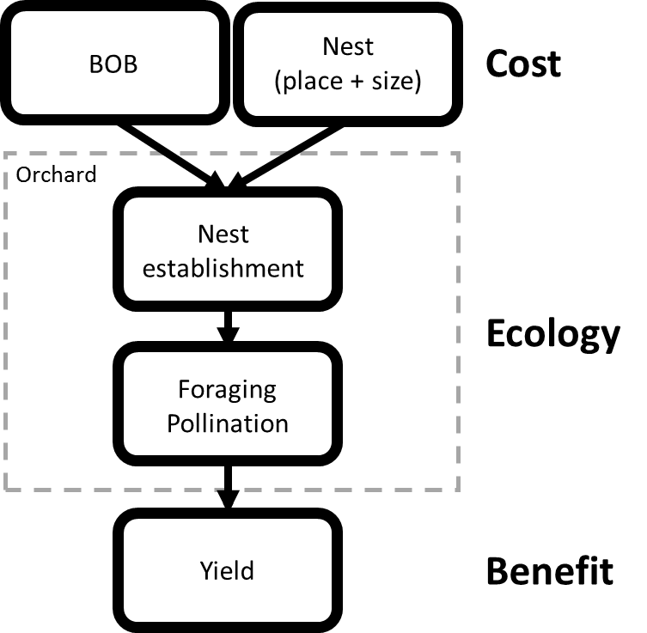

Figure 2. Study system in an almond orchard. (A) Blue orchard bee. (B) Nest box with 400 nest tubes. (C) Nest box with 100 nest tubes. (D) Experimental design and summary of field data. Size of symbols indicates relative number of filled nest tubes (gray rectangular) and sampled nut yields (orange circle). Blue orchard bee releasement sites are indicated as X. Two different colors of X indicate the center of two different types of plots with low (white X) and high (blue X) nest box densities, respectively.
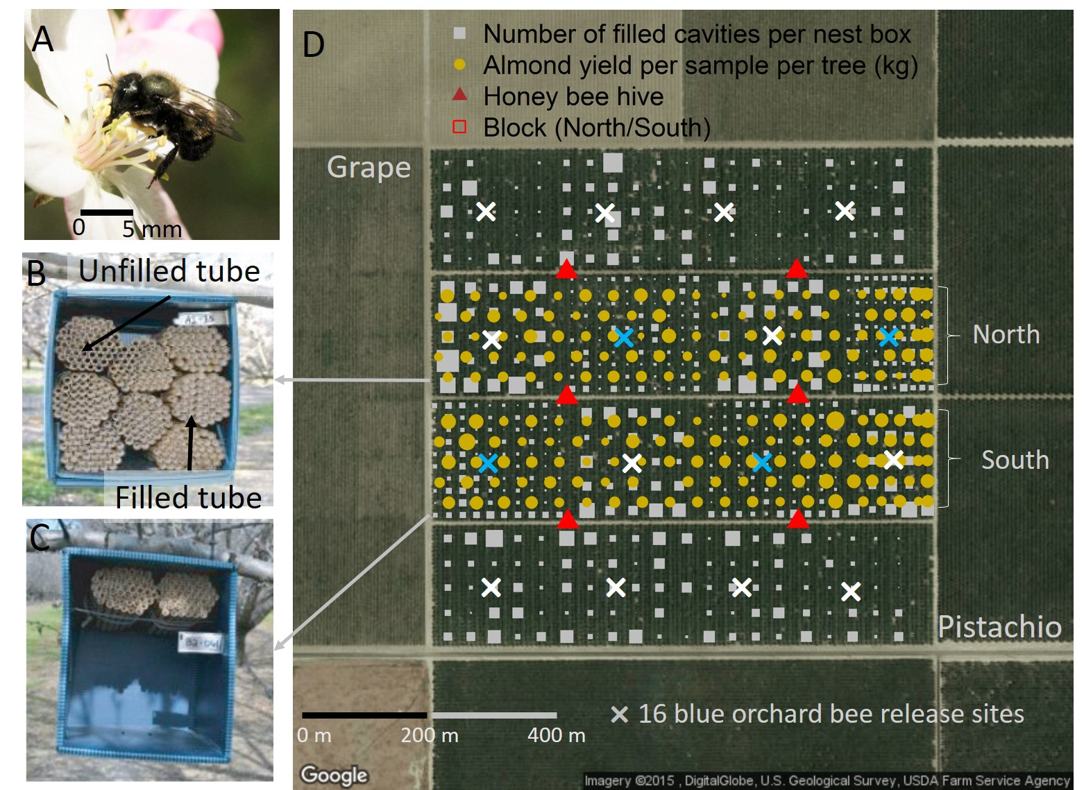

Figure 3. Nest establishment rate according to nest box density.

Figure 4. Parameterization and regression model of almond yields. (A) Model prediction from the selected the best-fit regression model with four variables (the foraging density of blue orchard bees and honey bees [BOB_{T} and HB_{T}], block effects [Block], and distance to boundary [Dist_{bound}]) for each distance decay parameters of blue orchard bee (P_{BOB}) and honey bees. Intercepts in the regression models are indicated as I. Negative relationships between variables and sampled nut yields are indicated in parenthesis. (B) Posterior distribution and 50% credible interval of P_{BOB} in Bayesian computation. (C) Relationship between BOB_{T} and sampled nut yields for individual trees in the best-fit regression model. (D) Relationship between Dist_{bound} and sampled nut yields in the best-fit regression model.

Figure 5. Estimated average net benefits (lines) and credible intervals (shaded areas) of nut yields according to different management scenarios for three levels of nest box density in an almond orchard (151 acres). (A) Predicted average net benefit and its credible interval for different number of released female BOBs. (B) Predicted average net benefit and its credible interval for different number of tubes per nest box when 64000 female BOBs were released. Shaded areas indicate 50% credible intervals.

Figure 6. Estimated average net benefits of nut yields on an almond orchard (151 acres) based on three different management variables: number of tubes per nest box, nest box density, and number of released female BOBs.

